**IPRO - 497 Integrating Hydroponics into the Workplace Environment**

**Student: Hong Zhang**

**An Intro to Green Walls**

Green walls are a main type of integrating hydroponics in the workplace environment. According to their construction techniques and main characteristics, we can subdivide green walls in two main systems: green facades and living walls. In our project, we choose to use living walls.

Green facades supports climbing or hanging plants growing upward from the ground away from the building1. Usually, green facades are used in outside building. In this category, it can be classified as direct or indirect. In direct green facades, plants are attached directly to the wall. Indirect systems need a variety of climbing plant material, can be customized and some are available in a variety of colors.

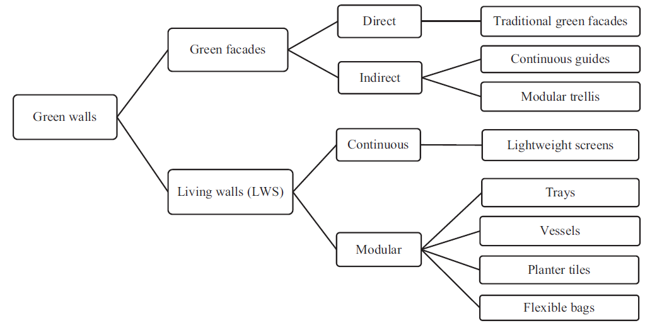

Fig. 1. Classification of green walls, according to their construction characteristics1

Living walls are a quite recent area of innovation in the field of wall cladding and we can use them outside or inside building. They are part of a building envelope system, comprising pre-vegetated or planted on-site panels containing plants, growing medium or liquid nutrient installed in or on a frame, secured to a structural wall or it can be free standing1. They can be divided into continuous and modular. Continuous living walls are based on the application of lightweight and permeable screens in which plants are inserted individually. Modular systems consist of square or rectangular panels that hold growing media to support plant material. The composition of the growing medium may be tailored to the unique combination of plants selected, and to other design objectives. Most of the nutrient requirements for the plants can be found in the growing media within the modules.

|  |  |  |  |  |
| --- | --- | --- | --- | --- |
| System | Category | Sub-category | Advantages | Disadvantages |
| Green facades | Direct greening | Traditional green  facades | No materials involved  Low environmental burden  Low cost | Limited plant selection/climate adaptability  Scattered growth along the surface  Maintenance problems |
| Indirect greening | Continuous guides | Vegetation development guidance  Low water consumption | Limited plant selection/climate adaptability  Scattered growth along the surface  High environmental burden of some materials |
| Modular trellis | Lightweight support | Controlled irrigation/drainage  Easiness to assemble and disassemble for maintenance | Limited plant selection/climate adaptability  High environmental burden of some materials  High installation cost |
| Living walls | Continuous systems | Lightweight screens | Flexible and lightweight  Increased variety of plants/aesthetic potential | Complex implementation  High water and nutrients consumption  Frequent maintenance |
| Modular systems | Trays | Easily disassembled for maintenance  Increased variety of plants/aesthetic potential  Controlled irrigation/drainage | Limited space for root development  High installation cost  Complex implementation  Surface forms limited to trays dimensions |
| Planter tiles | Increased variety of plants/aesthetic potential  Attractive design of modules | Limited space for root development  High installation cost  Complex implementation  Surface forms limited to tiles dimensions |
| Flexible bags | Adaptable to sloped surfaces  Increased variety of plants/aesthetic potential | High installation cost  Complex implementation  Heavier solutions due to growing media/limited to buildings maximum load |

Table 1: Comparison of green wall systems advantages and disadvantages 1

There are advantages and disadvantages in different systems. Depending on your demands, you can choose what you want. In our project, we choose to use trays because of easy disassembled for maintenance, variety of plants and controlled irrigation.

**HVAC (Heating, Ventilation and Air Conditioning)**

In our project, ventilation is very important. If we have a good air circulation and an exhaust system, it will protect plants against mold, bud rot and white powdery mildew, help control heat & humidity to create a perfect growing environment and strengthen stems by allowing them to bend & sway like in nature.

Ventilation is about controlling the quality of air, CO², heat and humidity2.

* **Heat**

The tolerate temperatures range for plants is 60°F ~ 92°F (17°C ~ 33°C) but their ideal temperature range is 70°F ~ 83°F (21.1°C ~ 28.3°C). For human, our ideal temperature range is 70.7°F ~ 75.2°F (21.5℃ ~ 24℃). Then, the good temperatures range for both plants and human is to stick around 72°F ~ 77°F (22.2°C ~ 25°C) when the lights are on. In the night, it should be reduced to 68°F (20°C).

As a reminder, when other conditions are correct, the rate of photosynthesis doubles for each 18°F (10°C) rises in temperature. This principle applies within the 50-86°F (10-30°C) range for temperate plants and 59-95°F (15-35°C) for tropical plants.

* **Humidity**

Plants ideal relative humidity levels are different in different stages. During cloning stage, the range is 80 ~ 90%. During vegetative growth stage, it is 60 ~ 70%. During flowering, it is 40 ~ 60%. However, human relative humidity level is 35 ~ 65%. In the workplace, the better humidity is 50 ~75% when lights are on. To keep in this range, in summer, use a humidifier to add additional moisture. During the winter months, use an extractor fan to replace fresh CO² rich air and for dehumidification (removing moisture), rather than reducing temperature.

* **CO²**

Carbon dioxide is an odorless gas and a minor constituent of the air we breathe. It comprises only .039 % (390 parts per million, or ppm) of the atmosphere but is vitally important to all life on this planet! Of course, indoor concentrations are different with the outside air. People exhale carbon dioxide—the average adult’s breathe contains about 35,000 to 50,000 ppm of CO2 (100 times higher than outdoor air) 3. In our project, there are 6 ~ 10 people for the small size. Hence, the carbon dioxide will reach to 210,000 ~ 500,000 ppm. The medium size which includes 10~14 people will produce 350,000 ~ 700,000 ppm of CO2. The large size which includes 14~18 people will produce 700,000 ppm ~ 900,000 ppm of CO2.

On the other hand, plants absorb CO2. The amount of CO2 which plants can absorb will depend on the amount of plants which are in the workplace. If the level of CO2 in the workplace is below 200 PPM, plants will not have enough CO2 to carry on the photosynthesis process and essentially stop growing. Levels of 800 - 1800 ppm have proven to be optimal for the majority of crops grown under protected cultivation and having CO2 monitoring equipment then becomes important to make sure this level is reached and maintained.

* **Layout for HVAC**

There are some special requirements for HVAC equipment. In HVAC system, we need extraction fans to facilitate air flow and prevent stratification, oscillating fans to help with air circulation, inlet fans to maximize the effectiveness and lifespan of the exhaust fan, thermometers and hygrometers.

In the dimensions part, we need to allocate sufficient clearance around the plants for maintenance and position plants at a convenient working height. It is beneficial to have a minimum gap of 1 meter (3 feet) between the lamp shade and the ceiling.   
The location of inlet, exhaust and oscillating fans is very important too. We need to keep the air moving in one direction as this creates and maintains air momentum. Then, we should locate the inlet fans and exhaust fans at opposite ends of the room, with an oscillating fan maintaining the general airflow direction provided by the inlet. For wider rooms especially, employ multiple inlets and exhausts, and space them evenly across the width of the room. For best airflow, keep objects at least 1 meter (3 feet) away from the fan inlet.

* **Controlling and optimizing HVAC system**

To optimize HVAC system, we can use a computer to set up a monitor system and control HVAC in the idea range which is showed in the table 2.

|  |  |  |
| --- | --- | --- |
|  | Range (Day) | Range (Night) |
| **Heat** | 72°F to 80°F (22.2°C to 27°C) | 15oC ~ 20oC (59oF ~ 68oF) |
| **Humidity** | 50-70% | |
| **CO²** | 390 ppm | |

Table 2: Requirements for HVAC

If thermostats and humidistats are out of the range, we can turn on or off the inlet and the exhaust fan. If the level of CO2 is lower than 390 ppm, we can use a tank of CO² to supply indoor insufficient CO².

There are some special tips in some extreme climates. In hot climates, uses air-condition to cool the incoming air, reduces the amount of lighting and uses insulation in the surrounding rooms so they do not amplify the temperature of the grow room. In cold climates, if the temperature is too low, considers pre-heating the incoming air. A fan speed controller is a useful addition where the fan's flow rate is too high during the colder or less humid months.

Reference:

1. Maria Manso, João P. Castro-Gomes , “Green wall systems: A review of their characteristics”, Renewable And Sustainable Energy Reviews · January 2015
2. “Hydroponics Ventilation Basics”, <http://www.ventilation-system.com/>
3. ASTM Standard D-6245 – 98 Using Indoor Carbon Dioxide Concentrations to Evaluate Indoor Air Quality and Ventilation